**API Testing using Postman**

**Project Title: Project X**

**Prepared by: Team BAMP**

**Faculty of Computing, Engineering and Technology**

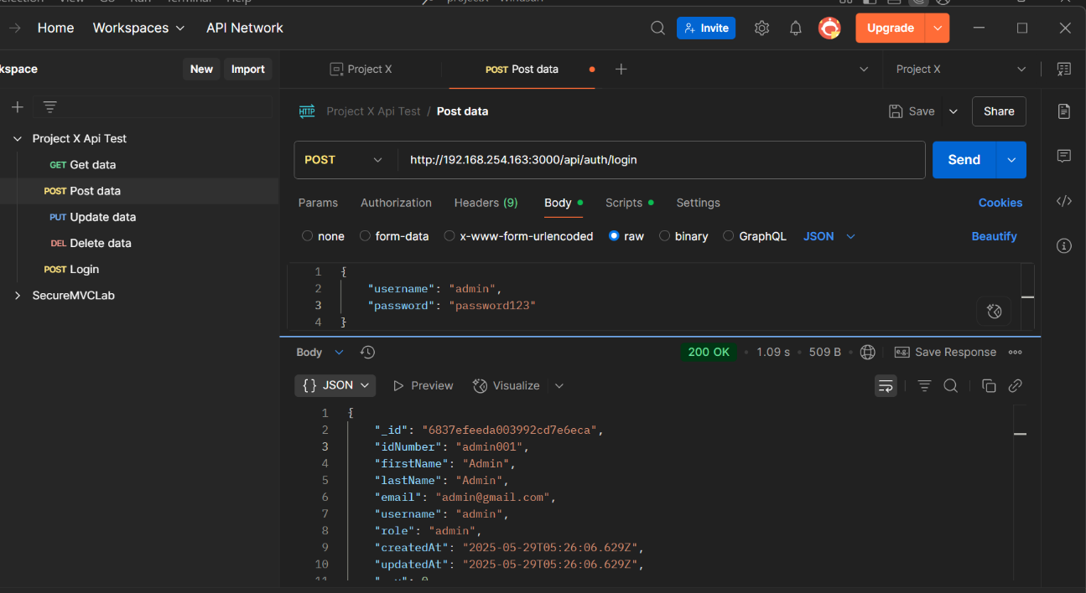**Api Testing login**

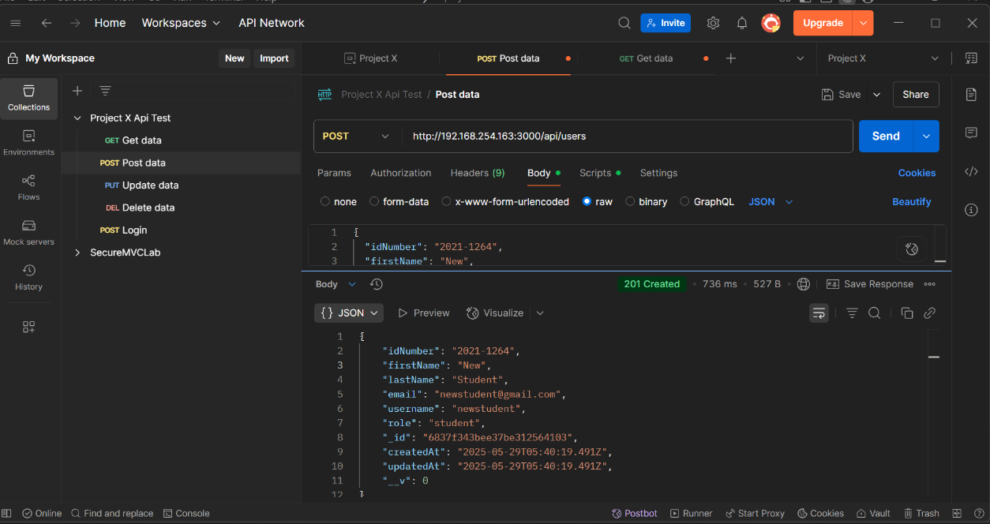**Users**

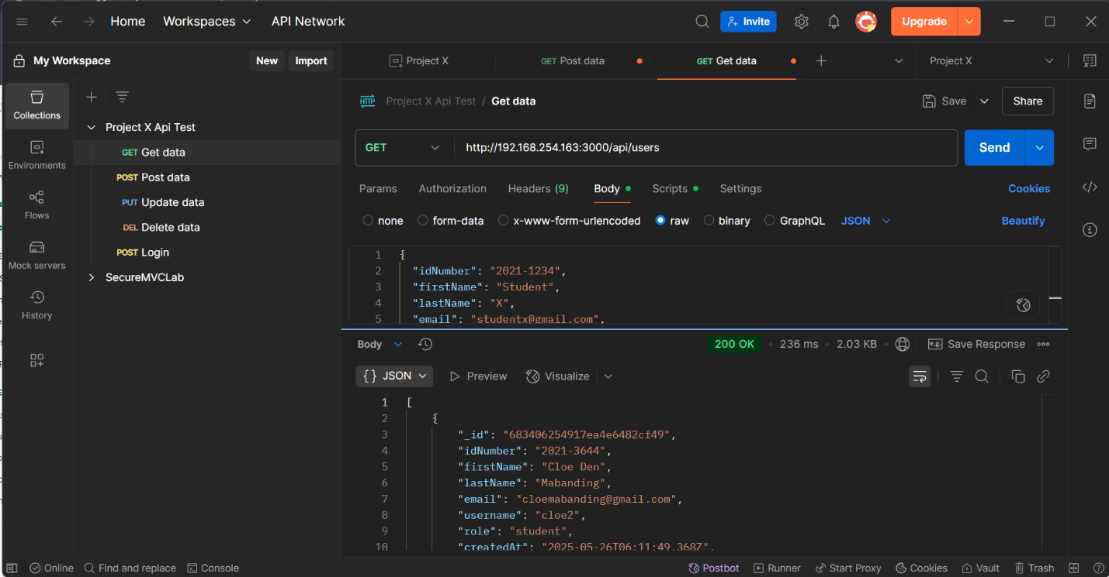**Create User**